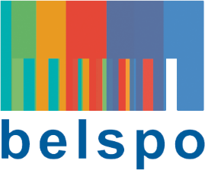

FEDERAL SCIENCE POLICY

RESEARCH PROGRAMME FOR EARTH OBSERVATION STEREO IV
(Support to Exploitation and Research in Earth Observation)

permanent call for proposals – DEvelopment of applications

Expression of interest

Mandatory for the submission of a research proposal

Please send to schy@belspo.be and vdab@belspo.be

PROPOSAL ACRONYM:

Coordinator:
Name: (name, first name)
E-mail:
Institution (acronym):
URL institution:

scientific PROMOTOR:
Name: (name, first name)
E-mail:
Institution (acronym):
Research unit:
URL research unit:
Core expertise promotor: | Remote sensing:
Other core expertise:

Other Project partners (optional):
Name + Organisation + URL research unit | Core expertise
 | Remote sensing | Other: specify

PROJECT INFORMATION:
Project title (maximum 12 words) :
Budget estimate (€)
Duration (months)
Short description (rationale, user needs, potential cost savings or business opportunities for coordinator, objectives, methodology, implementation/business plan…) (40 lines)
Research theme(s):
Impact of climate change on terrestrial and marine environments
Advanced Monitoring and Assessment of Hazards (including pandemics)
Monitoring environment for improved environmental health and biodiversity
Geo-information for Sustainable and Green Cities
Keywords:
Study site(s):

REFERENCES:
One key publication per scientific applicant(s) in the field of the proposal:
Five recent external key publications in the field of the proposal (by authors not belonging to the applying team(s):

