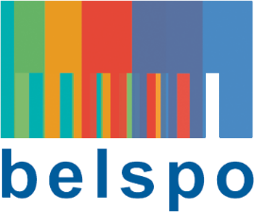

FEDERAL SCIENCE POLICY

RESEARCH PROGRAMME FOR EARTH OBSERVATION STEREO IV
(Support to Exploitation and Research in Earth Observation)

permanent call for proposals – DEvelopment of applications

Pre-study submission file

Please send to schy@belspo.be and vdab@belspo.be

ACRONYM:

Coordinator:
Name: (name, first name)
E-mail:
Tel:
Organisation (name and acronym):
Organisation type:
Private company
Public administration
Core business:
URL:

Project partners:
Name + Organisation + URL
Scientist in charge of carrying out the project:

PROJECT INFORMATION:
Project title (maximum 12 words) :
Keywords:
Budget(in €):
Budget breakdown:
Duration:
Description (including current relevant knowledge within project team, objectives and tasks):
User need and potential users:
Current approach to fulfil user needs (if any):
Deliverables:
How would the developed application be integrated and used by the coordinator after the end of the project:

: The budget should not exceed 10.000 €
: The maximum duration is 6 months

