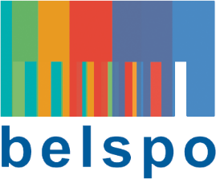

FEDERAL SCIENCE POLICY

RESEARCH PROGRAMME FOR EARTH OBSERVATION STEREO IV
(Support to Exploitation and Research in Earth Observation)

permanent call for proposals – Dissemination and support projects

Submission file

Please send to schy@belspo.be and vdab@belspo.be

title (maximum 12 words):

acronym:

promotor:
Name: (name, first name)
E-mail:
Tel:
Institution (acronym):
Research unit:
URL research unit:

Project partners (optional):
Name + Organisation/Research Unit + URL

PROJECT INFORMATION:
Name mother project (optional):
Output type:
Paper:
Data paper:
Software:
Connection between STEREO projects:
Small specific research:
TERRASCOPE Jupyter notebook:
Training grant:
Other (specify):
Description (including objectives and tasks):
Deliverables:
Scientist in charge of carrying out the project:
Link with mother project (optional):
Justification (visibility Belgian EO research, support to EO community, …):
Budget estimate (in €):
Budget breakdown:
Estimated duration:

: The budget should not exceed 30.000 €
: The maximum duration is 6 months

